**SQL (Structured Query Language)** is a computer language used to interact with relational databases, allowing users to organize, manage, and retrieve data from these databases. [It provides a way to define data structures, retrieve information, and perform data manipulation tasks](https://www.geeksforgeeks.org/what-is-sql/) [1](https://www.geeksforgeeks.org/what-is-sql/).

Here are **five free resources** where you can learn SQL:

1. [**W3Schools SQL Tutorial**](https://www.w3schools.com/sql/): This comprehensive tutorial covers SQL for various database systems, including MySQL, SQL Server, Oracle, and more. [It includes examples, exercises, and a reference section](https://www.geeksforgeeks.org/what-is-sql/) [2](https://www.w3schools.com/sql/).

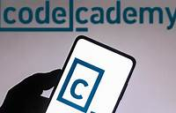

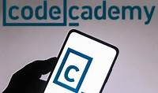

1. [**Codecademy’s Learn SQL**](https://www.codecademy.com/learn/learn-sql): Codecademy offers interactive lessons on SQL manipulation, queries, aggregate functions, and more. [It’s a great place to start learning SQL](https://www.geeksforgeeks.org/what-is-sql/) [3](https://www.codecademy.com/learn/learn-sql).
2. [**Essential SQL For The Beginners**](https://www.sqltutorial.org/): This resource introduces SQL syntax, querying data, and provides examples using an HR sample database [4](https://www.sqltutorial.org/).

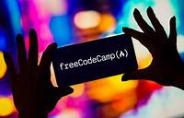

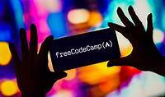

1. [**freeCodeCamp’s Relational Database Curriculum**](https://www.freecodecamp.org/news/learn-sql-free-relational-database-courses-for-beginners/): Explore freeCodeCamp’s SQL courses, including tutorials on MySQL, SQLServer, and more [5](https://www.freecodecamp.org/news/learn-sql-free-relational-database-courses-for-beginners/).

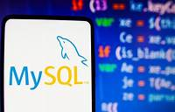

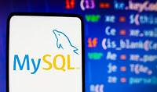

1. [**MySQL Database - Full Course** (YouTube): This video course by freeCodeCamp covers MySQL from beginner to advanced levels](https://www.geeksforgeeks.org/what-is-sql/) [5](https://www.freecodecamp.org/news/learn-sql-free-relational-database-courses-for-beginners/).

Happy learning! 📚👩‍💻